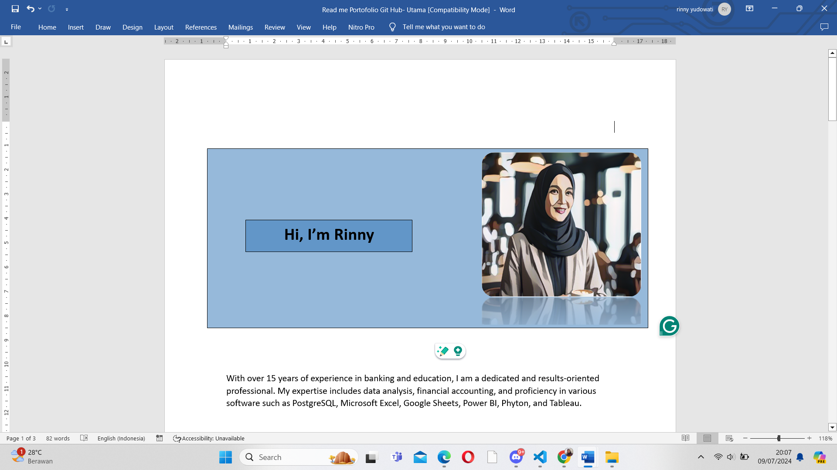

Hi, I’m Rinny

**Hi, I’m Rinny**

With over 15 years of experience in banking and education, I am a dedicated and results-oriented professional. My expertise includes data analysis, financial accounting, and proficiency in various software such as PostgreSQL, Microsoft Excel, Google Sheets, Power BI, Phyton, and Tableau.

**Gambar masing2 dari :**

Postgre SQL ,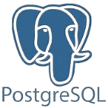

Microsoft Excel, 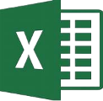

Google Sheets & Docs, 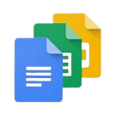

Power Point,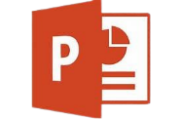

Office 365 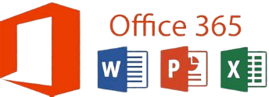

Microsoft Word,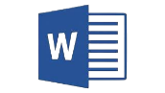

Research & Analysis ,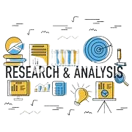

Phyton, 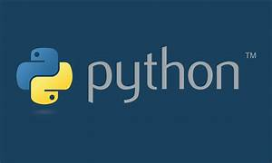

Leadership,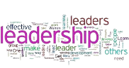

Power BI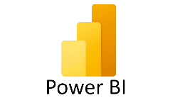

Tableau

Financial Analysis, 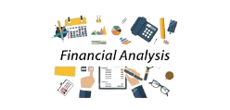

Banking Knowledge,

Communication, 

Interpersonal Skills, 

Marketing, 

Community Engagement, 

Teamwork, 

Problem Solving